**Exp12 Code:-**

using System;

using System.Collections.Generic;

using System.ComponentModel;

using System.Data;

using System.Drawing;

using System.Linq;

using System.Text;

using System.Windows.Forms;

using System.Data.SqlClient;

namespace DBconExp12

{

public partial class Form1 : Form

{

SqlConnection con = new SqlConnection(@"Data Source=.\SQLEXPRESS;AttachDbFilename=C:\users\db lab 9\documents\visual studio 2010\Projects\DBconExp12\DBconExp12\Database.mdf;Integrated Security=True;User Instance=True");

public Form1()

{

InitializeComponent();

}

private void button1_Click(object sender, EventArgs e)

{

con.Open();

SqlCommand cmd = con.CreateCommand();

cmd.CommandType = CommandType.Text;

cmd.CommandText = "insert into Books(Title,Author,Publisher) values('" + textBox1.Text + "','" + textBox2.Text + "','" + textBox3.Text + "')";

cmd.ExecuteNonQuery();

con.Close();

textBox1.Text = "";

textBox2.Text = "";

textBox3.Text = "";

disp_data();

MessageBox.Show("Record Inserted");

}

public void disp_data()

{

con.Open();

SqlCommand cmd = con.CreateCommand();

cmd.CommandType = CommandType.Text;

cmd.CommandText = "select *from Books";

cmd.ExecuteNonQuery();

DataTable dt = new DataTable();

SqlDataAdapter da = new SqlDataAdapter(cmd);

da.Fill(dt);

dataGridView1.DataSource = dt;

con.Close();

}

private void button2_Click(object sender, EventArgs e)

{

con.Open();

SqlCommand cmd = con.CreateCommand();

cmd.CommandType = CommandType.Text;

cmd.CommandText = "update Books set Title='" + textBox2.Text + "' where Title='" + textBox1.Text + "'";

cmd.ExecuteNonQuery();

con.Close();

disp_data();

MessageBox.Show("Record Updated");

}

private void button3_Click(object sender, EventArgs e)

{

con.Open();

SqlCommand cmd = con.CreateCommand();

cmd.CommandType = CommandType.Text;

cmd.CommandText = "delete from Books where Title='" + textBox1.Text + "'";

cmd.ExecuteNonQuery();

con.Close();

disp_data();

MessageBox.Show("Record Deleted");

textBox1.Text = "";

textBox2.Text = "";

textBox3.Text = "";

}

private void button4_Click(object sender, EventArgs e)

{

con.Open();

SqlCommand cmd = con.CreateCommand();

cmd.CommandType = CommandType.Text;

cmd.CommandText = "select *from Books where Title='" + textBox1.Text + "'";

cmd.ExecuteNonQuery();

DataTable dt = new DataTable();

SqlDataAdapter da = new SqlDataAdapter(cmd);

da.Fill(dt);

dataGridView1.DataSource = dt;

con.Close();

}

private void Form1_Load(object sender, EventArgs e)

{

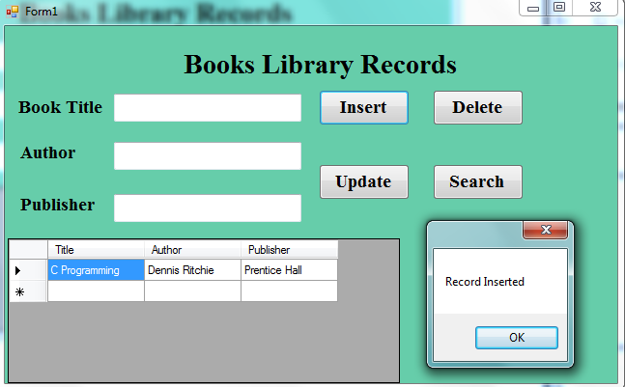 disp_data();

}

}

}

**Output:-**

**Insert Record:-**

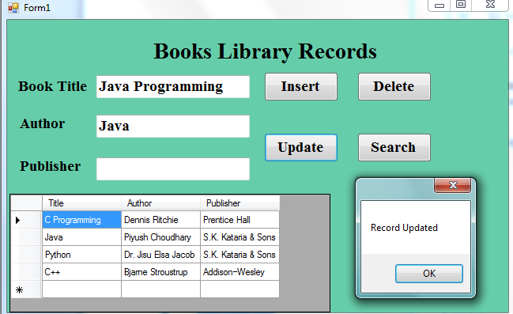

**Update Record:-**

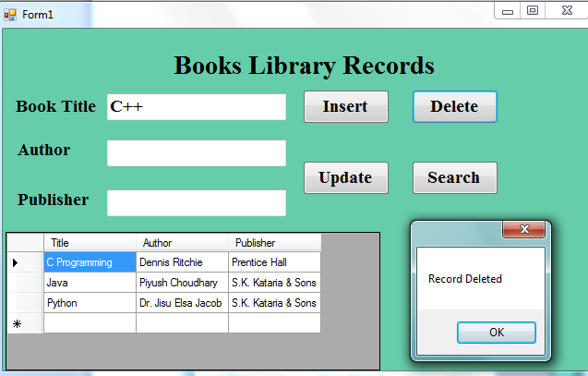

**Delete Record:-**

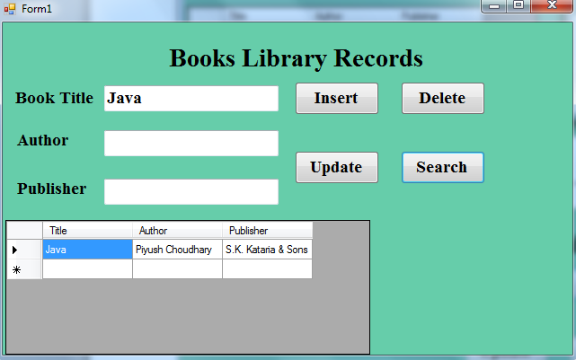

**Search Records:-**